

Scripting Project

SSH Honeypot for Behavioural Logging and Forensic Data Capture

Aidan Denner
CMP509: Ethical Hacking
MSc Ethical Hacking with Cybersecurity
2024/25

Note that Information contained in this document is for educational purposes.

Abstract
As cyber threats grow in sophistication and complexity, understanding what the attacker’s mindset is has never been more essential. This project explores the creation of an SSH honeypot, designed to act as cyberbait, mimicking a real system to lure attackers and record their interaction for analysis. Honeypots are an essential tool for gathering intelligence on attacker behaviour by creating the illusion of being a real target within a network.
This project focuses on developing an SSH Honeypot written using the Python programming language, with the intention of honeypot activity for forensic analysis. This honeypot emulates an interactive shell environment complete with commands such as ls, Ifconfig, echo and whoami to deceive threat actors and document their tactics in a controlled setting, contributing to understanding the new threats and tactics employed by attackers when attempting to exploit the SSH protocol. The honeypot utilises various features alongside Python, such as the paramiko library to simulate the SSH protocol, alongside Python's logging module to structure the activity logs. Docker was used to help isolate the system, but also to remove the effort of getting it to work across multiple systems. The honeypot successfully fulfilled the design objectives, capturing relevant session data and showcasing the effectiveness of low-interaction deceptive techniques. The project also contributes to a broader understanding of how attackers target SSH services and lays a solid foundation for further enhancements to threat intelligence methods.

Contents
1 Introduction 1
1.1 Background 1
1.2 Aim 1
1.3 Threat Model 1
1.3.1 Assets 1
1.3.2 Threat Actors 2
1.3.3 Attack Vectors 2
1.3.4 Attacker goals 2
1.3.5 System assumptions and limitations 2
2 Procedure 3
2.1 Overview of Procedure 3
2.1.1 Planning and Design 3
2.1.2 Development 3
2.1.3 Tools used 3
2.1.4 Testing 4
2.2 Methodology 4
2.2.1 Requirements 4
2.2.2 Technology 4
2.2.3 Development Stages 5
2.2.4 Ethical Considerations 5
2.3 System Design and Implementation 5
2.3.1 System Overview 5
2.3.2 Other Honeypot models 5
2.3.3 System Architecture 6
2.3.4 Core components 7
2.3.5 Security Considerations 7
2.4 Development 8
2.4.1 Starting the SSH Honeypot 8
2.4.2 Handling Authentication 9
2.4.3 Capturing Login Attempts 9
2.4.4 Simulating the Shell 9
2.4.5 Logging Activity 10
2.4.6 Dockerfile 10
2.5 Testing 11
2.5.1 Testing Disclaimer 11
2.5.2 Function Testing 11
3 Discussion 12
3.1 General Discussion 12
3.2 Evaluation and Future Work 15
4 References 16
Appendices 18
Appendix A - Flowchart 18
Appendix B – Pseudocode 19
Appendix C – Dockerfile 19
Appendix D – Source code 20
Appendix E – Testing Evidence 30
4.1.1 Docker Container 30
4.1.2 Authentication 30
4.1.3 Commands 30
4.1.4 Logging 32

Introduction

Background
As the world becomes more interconnected daily, with the rise of smart devices and our reliance on digital devices for day-to-day activities, the demand for better cybersecurity also increases. Attackers are always looking for just one tiny gap in a network to exploit with the intent of committing further offences. One attack vector that is still commonly exploited today is the Secure Shell (SSH) protocol. This protocol is often used for remote system administration, and attackers frequently target open SSH ports using brute-force techniques or by exploiting misconfigurations.
Honeypots are a deceptive countermeasure to situations such as this and are designed to be attacked, as from the attacker’s perspective, they look like promising entry points to a network (SentinelOne, 2025). They are monitoring tools that researchers and analysts use to observe hacker behaviour in real-time while keeping the real targets free from sabotage. This project will follow the development of an SSH honeypot written in Python, with a focus on capturing attacker interactions for further analysis and intelligence gathering.

Aim
The primary aim of this Python scripting project is to develop and test a lightweight SSH honeypot capable of recording attacker interactions and presenting them in a neat manner that will make analysis easier. The honeypot will simulate a basic Linux shell environment, log any activity within the honeypot, and store authentication attempts for later analysis. The following are the objectives to support this aim:
- Develop a Python-based SSH honeypot that mimics a legitimate open service and a shell session.
- Log user input, credentials, and session activity.
- Enhance the realistic nature of the honeypot with basic shell commands and responses.
- Identify limitations and propose improvements for future versions.

Threat Model
This threat model focuses on simulating a realistic target for unauthorised users attempting to gain access to remote systems via SSH.

Assets
The honeypot is designed to resemble a standard Linux server. Ideally, the attacker will perceive the following ‘assets’ as something worth exploiting:
- Lists user accounts with administrator access.
- Simulated file systems (e.g. /home, /etc).
- Potential configuration files and credentials.
- System-level access and privilege escalation opportunities.
- A platform to allow the use of malware.

Threat Actors
The honeypot will be designed to respond to all manner of threat actors, such as the following:
- Automated scanners or Bots – These tools will scan IP addresses in ranges and can brute force credentials where prompted.
- Script Kiddies – These are inexperienced attackers running prebuilt scripts or automated tools, with the same intent as experienced attackers.
- Experienced adversaries – These people are individuals exploring the system manually, with methods that include enumeration on services, users and files.

Attack Vectors
These are some common attack vectors that threats will often take advantage of when entering a network:
- Brute-force login attempts – Repeated username and password combinations with the intent to eventually gain access. This could also take the form of Dictionary attacks.
- Command execution – Attempts to interact with the system post-login (cat, cd, ls, wget).
- Reconnaissance – Enumeration of users, processes, system versions and files.

Attacker goals
When attackers target a network, they can have many goals and intentions towards it, including:
- Harvesting credentials.
- Testing exploits and payloads.
- Mapping environments.
- Using the system to piggyback onto other attacks.

System assumptions and limitations
This honeypot will assume the following about attackers:
- They are not conducting deep analysis, such as checking kernel versions and inconsistencies.
- They will attempt to use common commands found in Linux environments.
- They do not expect fully functioning shells such as nano.

Procedure

Overview of Procedure
The project followed a structured process of 20% planning, 60% development and 20% testing. The overall approach was grounded in cybersecurity practices focused on capturing attacker interaction while maintaining high safety standards and system isolation.

Planning and Design
Planning involved researching existing honeypot solutions and how attacker behaviour factors into the effectiveness of the honeypot. These design considerations included:
- Minimal footprint to avoid detection.
- Compatibility with modern hacking tools.
- Simplistic logging mechanisms for usability.
- Basic Linux command simulation to sustain engagement.
During planning, some pseudocode and a network flow diagram were written (See Appendices A and B) to guide implementation and to understand how the honeypot functions from an outside perspective.

Development
The honeypot was developed using Visual Studio Code with Python as the language, largely due to its simplicity and extensive libraries. The libraries used were the following:
- Paramiko - This library implemented the SSH server functionality. Handling key exchange, user authentication, and the interactive shell (Paramiko, n.d.).
- Socket - This provides low-level networking capabilities to listen for incoming connections.
- Threading - Allowed concurrent handling of multiple incoming SSH sessions to simulate multi-user environments.
- Datetime - This allowed timestamping of each command entered by the attacker to make accurate session logging for easier analysis.
- Os and sys - Used for basic system-level operations such as file path simulation
These libraries enabled the creation of a responsive SSH environment that logs interactions while appearing to be convincingly real to outside threats.

Tools used
To achieve the desired outcome of the project, the following tools were used:
- Visual Studio Code – This was the main tool used to write the code for the honeypot
- Kali Linux VM – Most of the coding was done inside Kali Linux alongside its shell for testing.
- Python – This was the chosen programming language for the whole honeypot.
- Docker – This was used to containerise the honeypot for security and portability.
- Ray.so – This web app was used to display the code in a neat format for easier readability in this report.

Testing
The testing phase focused on verifying that each component of the honeypot worked as expected. All testing was performed within a Kali Linux VM, leveraging its penetration testing toolset.
Key areas that were testing include:
- Connection Handling – Ensuring the server correctly accepts SSH connections and logged all attempts.
- Activity Logging – Checking that all input was recorded accurately to the log file, with the correct timestamps for readability and clarity.
- Fake Command Responses – Confirming that basic commands (ls, cat, whoami, etc) returned convincing responses to retain the illusion that what is being interacted with is a real shell.
- Session Stability – Verifying that a stable shell prompt was presented and could handle all user input without crashing.
To support the portability and ease of distribution, a Dockerfile was created. This allows for the honeypot to be executed reliably on other systems.

Methodology
The methodology used for this project is an agile, iterative development methodology. This allowed for the greatest amount of flexibility and adaptability throughout the development process (Laoyan, 2025). Development was broken into stages, starting with SSH Emulation, command logging, structuring, and finally Docker containerisation. Each stage involved short cycles of development, getting each stage completed and working first before moving onto the next stage. If development halted due to bugs and fixes, then previous areas could be visited to help fix future issues. This does mean predicted outcomes are different from the final build, but it does allow the project to shift comfortably throughout development, tackling unpredictability with rapid bug fixes and ensuring the final build is stable.

Requirements
The first step was to identify what the core functionality of the honeypot will need: It needs to mimic a real server with a believable interactive CLI, the ability to log interactions, all while storing this in a clean and readable format for easier forensic analysis. The system also needed to be portable and isolated; this is where Docker comes into play.

Technology
Python was the chosen programming language due to being highly versatile, with extensive libraries and modules, and a wealth of community support. The Paramiko library was used for SSH simulation as it supports both client and server-side protocols (Paramiko, n.d.). Docker was used to isolate the honeypot from the host system, but it was primarily selected to ensure the honeypot is portable across a wide range of devices. While the script can be run within the host machine without Docker, it is advisable to use it, as it makes the process of using the script much easier (Docker, n.d.).

Development Stages
The honeypot was developed in incremental stages:
- SSH Connection and handling were prototyped with paramiko first. A connection must be established first before the rest of the functionality can be tested.
- Logging functionality was started to show that data can be collected from the honeypot upon connection. This was achieved using the logging module (Python Software Foundation, 2023).
- Command functionality was the next stage of development, focusing on how each command outputs information back to the user and how they can navigate the honeypot. This information was then recorded into the log file, feeding into the logging functionality.
- Finally, a Dockerfile was created and then tested inside the container for secure containerisation.
All testing was done locally on a Kali Linux VM to reduce the risk of unintentional exposure to the public internet. Afterwards, testing was done on Windows via PowerShell inside the Docker container.

Ethical Considerations
For ethical and security reasons, the honeypot was tested using scripted attacker behaviour without any real-human interaction. This allowed for controlled, simulated testing to validate and test all core functionality in an efficient and ethical manner.

System Design and Implementation

System Overview
The system is a Python-based honeypot that mimics a real SSH server using the paramiko library. It can accept incoming connections, log the authentication attempts, and present a simulated shell to attackers, making them think they are in a real shell. All interactions with the server are logged in a file with a format that is easy to read, so forensic analysis can be performed more efficiently and with less confusion. While the honeypot can be run directly on Windows through PuTTY or within a Linux VM, it is primarily designed to be run from inside a Docker container, so it is more isolated and compatible with a wider range of machines (Docker, n.d.).

Other Honeypot models
The main design of this honeypot and its requirements shares common functionality with already established honeypot models, each of which differs in scope and complexity:
- HoneyPy – This is a low to medium-interaction honeypot designed to be lightweight and modular. Like this project, it uses fake services such as the emulation of SSH. However, HoneyPy offers more than just SSH emulation and supports external log forwarding features, whereas for this project only local logging and SSH are supported.
- Cowrie – This is a medium to high-interaction honeypot that supports SSH and Telnet. It has the ability to emulate full file systems and even supports file uploads and command execution within its environment. Unlike Cowrie this project avoids any form of file upload capabilities and keeps all interactions within a fake shell and fake commands.
- T-Pot – This is a professional-grade, all-in-one honeypot platform that integrates multiple honeypots (like Cowrie) into a centralised system, that offers real-time threat feeds and a full dashboard experience. This is a huge piece of software that involves a lot of collaboration with a large number of people. In contrast, this project is single-purpose, designed to add clarity to logs, run everything in a safe and controlled environment with minimal dependencies.

System Architecture
The SSH Honeypot is designed to be very modular and to have separate responsibilities across each component, ensuring clarity and scalability. It was developed to run mainly inside a Docker container however, it is possible to run it directly on a machine. However, if running on an older Windows system, PuTTY is recommended to ensure compatibility. For a project such as this, Docker is the recommended way to run it because it keeps everything isolated and ensures portability across various systems. The honeypot consists of four key modules:
- SSH Emulation – This area utilises the paramiko library to simulate an SSH Server and listens on port 2222 for incoming connections. When a connection is established, it captures data such as the username, password, IP address and the timestamp of when the event took place. In the base build of the honeypot, there is no authentication required, however, it can be easily modified to only accept specific credentials if desired.

- Fake Shell – Upon login, the honeypot presents itself as a real shell environment, with commands such as ‘ls’ for listing directory items, ‘cd’ for changing directories, and ‘cat’ to display file contents. When a command is entered into the ‘shell’, it is recorded into a file that is updated in real time, allowing an analyst to easily monitor activity.

- Logging – All connections and session activity is stored in the .log format with the logs being separated by session to make analysis more streamlined. This way analysts have a full timeline of each intrusion attempt.

- Docker – The entire system is designed around being able to run in Docker, which includes the main honeypot script, logging infrastructure, as well as all the libraries used. With Docker, it ensures that the environment can be deployed on any machine without any dependency problems. The Docker container only exposes the emulated SSH port and isolates the honeypot from the host system.

- Scalability
The code is very modular, with the SSH handling, shell simulation, and logging all separate from each other. Docker allows deployment in almost every environment, provided Docker is installed. It could potentially be deployed on other services such as FTP, another target common in cyberattacks.
For an overhead view of how the honeypot functions, a flowchart diagram can be seen in Appendix A. For a simplistic understanding of how the honeypot is meant to function, some pseudocode can be found in Appendix B.

Core components

Component | Breakdown
SSH Emulation | - ‘paramiko.Transport’ is used to accept connections to the honeypot.  - Connections are threaded for multiple sessions.
Fake Shell | - Reads commands with ‘chan.recv()’  - Responds with fake outputs, making the user believe they are in a real shell (i.e ls, cd, whoami).  - The shell does not process commands like a real shell; it simply outputs a pre-configured response.  - The directory traversal commands are more believable as it is very close to how you would see them in a real shell.
Session Manager | - Stores login attempts and shell activity using threading.  - Each session is isolated and logged individually.
Logging System | - Structured logs using Python's logging module.  - Logs are stored in the main directory, and access depends on where the script is running.
Docker Container | - Dockerfile cleanly builds the environment with all dependencies.  - Exposes SSH port 2222.
Table 1 - Core components

Security Considerations

- Threading – The honeypot takes advantage of the threading module to support simultaneous connections, with each session running in its own thread.

- Fake Shell Loop – The fake shell runs on a loop, constantly asking for commands from the attacker unless they type ‘exit’ or forcibly close the session. No real system interaction is taking place to ensure security integrity is high.

- Extra Commands – Additional command parsing was included such as ‘whoami’, ‘echo’, ‘ps aux’ and ‘ifconfig’ to make it look more like a real Linux shell without interfering with real systems.

- Service Isolation - The honeypot binds to a non-standard port (e.g. 2222) to avoid interference with real services running on the host machine.

- Docker Container – The Docker container has no outbound connections, limiting the case of real exploitation attempts.

Development
The section highlights the key parts in the development of the SSH Honeypot and how each part of the core functionality was achieved. Explanations on design decisions will also be provided.

Starting the SSH Honeypot
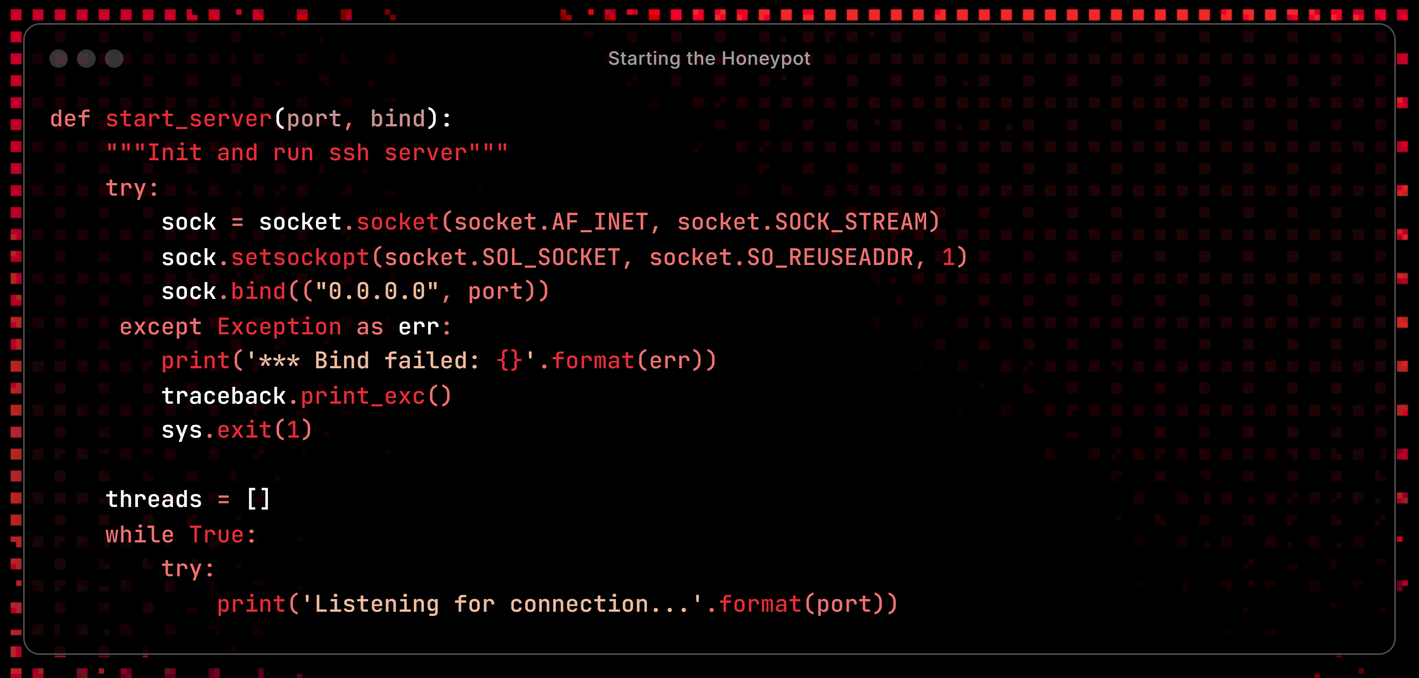
Figure 1 - Starting the Honeypot
This function sets up the honeypot's SSH server. When the script is run, it creates a TCP socket that binds to all interfaces on a specific port and listens for incoming connections. Thanks to the use of the threading module, for each connection, a new thread is spawned to handle the client, and this ensures the honeypot can handle new connections simultaneously.

Handling Authentication
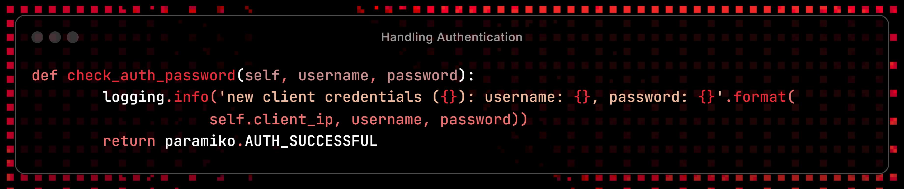
Figure 2 - Handling Authentication
This method is set to accept any username and password and simulates a successful login to lure attackers deeper into the honeypot. The method has also been developed to be modular, so if a specific username and password were to be required, it is very easy to do so; the comments for this can be seen in Appendix C.

Capturing Login Attempts
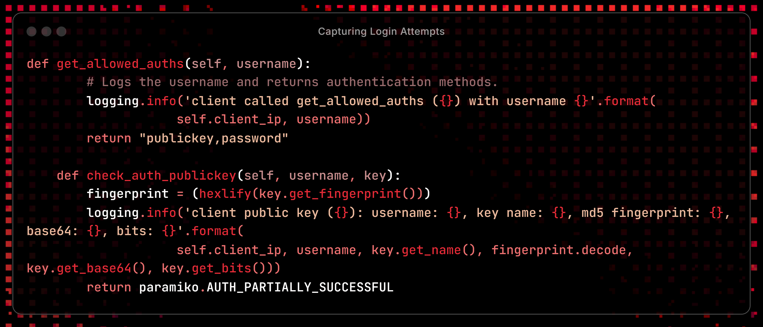
Figure 3 - Capturing Login Attempts
These two methods support both public key and password authentication. The ‘get_allowed_auths’ method shows valid authentication methods, while ‘check_auth_publickey’ captures details about the attacker's SSH key, such as the username and fingerprint.

Simulating the Shell
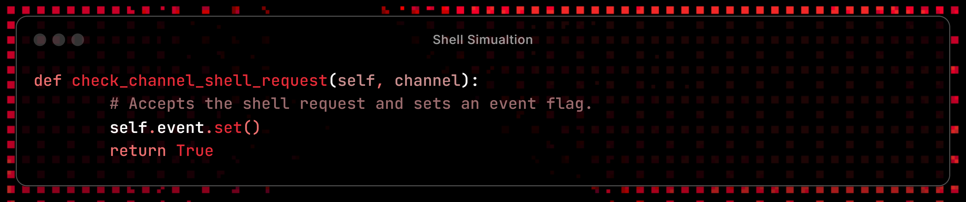
Figure 4 - Shell Simulation
This function allows the honeypot to accept the request made by the user for entry into the honeypot. The user is prompted for input in the current directory. Any command entered is logged and sends back fake outputs to the user. Recognisable commands include ls, cd, whoami and cat. The whole list can be found with the ‘help’ command. The method used to configure the fake directories can be found in Appendix C.

Logging Activity
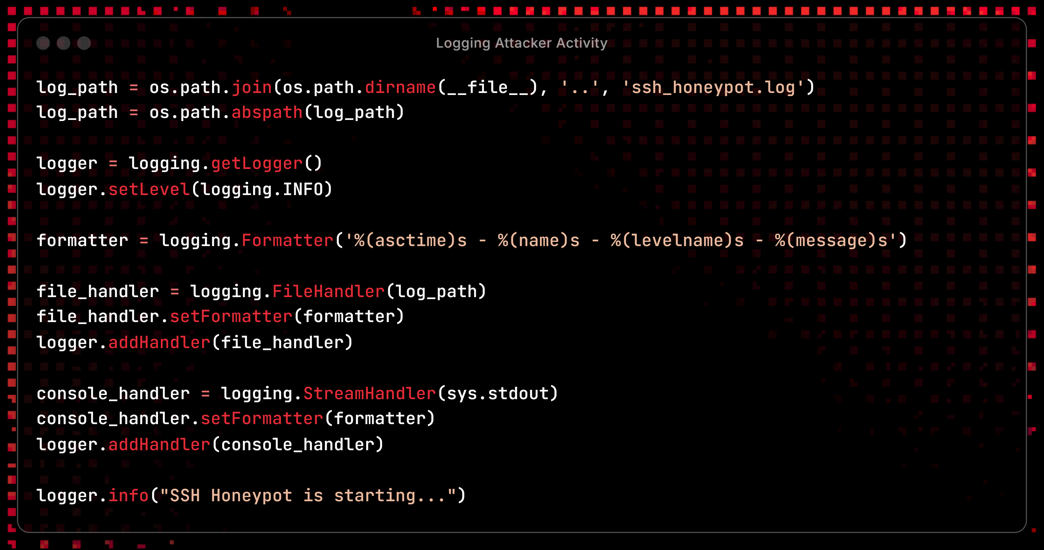
Figure 5 - Logging Attacker Activity
Logging is configured in two ways: it captures console output and writes to a file located in the project's root folder. It records information such as timestamps, log level, and the commands entered by the attacker. Every event is logged, from the moment they enter the honeypot to the moment they exit. The logs are displayed in a neat format that makes post-analysis much easier (Python Software Foundation, 2023).

Dockerfile
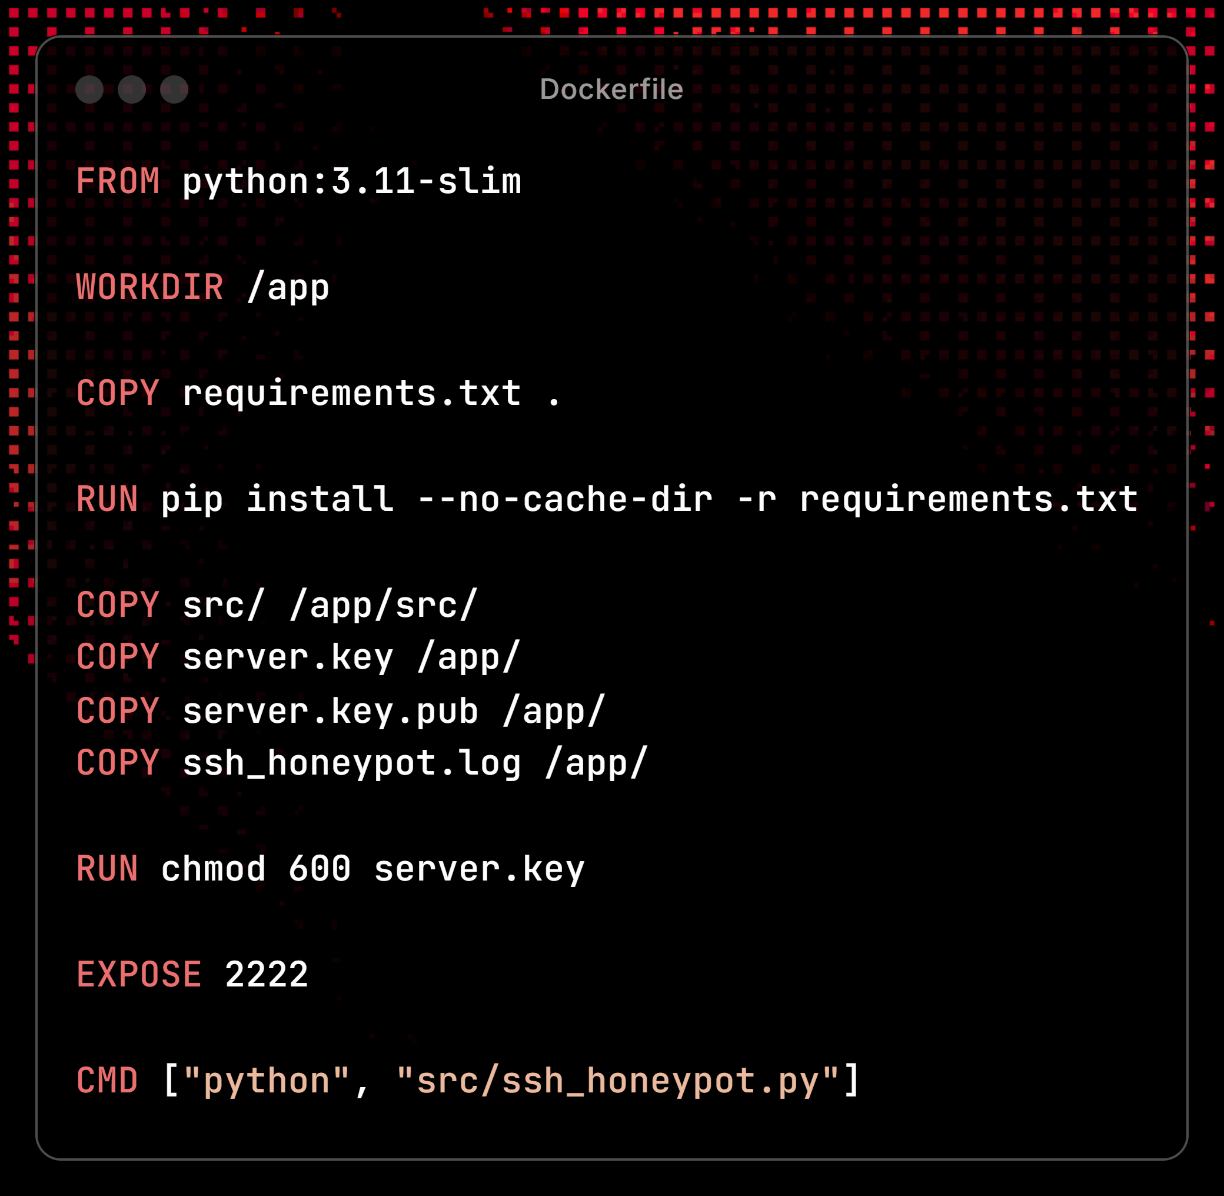
Figure 6 - Dockerfile
The Dockerfile defines a lightweight Python container using ‘python:3.11-slim’. It sets /app as the working directory and copies the honeypot files into the container so they can be utilised. Dependencies are installed via ‘requirements.txt’. The SSH port 2222 is exposed (default is 22), and the script is run using CMD. This setup ensures consistent deployment for testing and analysis across a wide range of environments.

Testing

Testing Disclaimer
All tests use scripted attack behaviour and are carried out in a controlled environment for ethical reasons. Attack methods included only the tester, and no social engineering was conducted during the testing phase.

Function Testing
All testing evidence can be found in Appendix D.
Function | Description | Pass/Fail
Starting the Server | Run the honeypot and check listening on port 2222. | Pass
Authentication Handling | Attempt to log in with any credentials. | Pass
Command Handling | Enter commands such as ls, cd, ifconfig, help and echo. | Pass
Log generation | The log file is updated as command activity occurs inside the honeypot. | Pass
Docker container | Honeypot is running smoothly inside the Docker container. | Pass
Key Handling | Connect with the SSH key and fingerprint | Pass
Table 2 - Function Testing

Discussion

General Discussion
At its core, a honeypot's primary function is to collect network-security intelligence by serving as a decoy to lure attackers inside (Rowe, 2018) (Javadpour, et al., 2024) (Vaidesswaran, 2025) as opposed to preventing them from getting in full stop. This approach yields a vast amount of information with the added benefit of having a low false positive rate (Javadpour, et al., 2024). By diverting the threat away from siphoning valuable information, honeypots work wonders in the security industry as a powerful tool for understanding threats and enhancing network defences (Rowe, 2018). While security experts might not know it at present, the information they collect could mean a different outcome for a future attack they would not have been prepared for (Kosinski, 2025).

A key principle of how honeypots are so effective is their ability to be deceptive (Rowe, 2018). Attackers will usually actively attempt to avoid them because the decoys will lack the information they seek, and they have safeguards in place to prevent them from being pivoted off to launch a real cyber-attack (Rowe, 2018). Honeypots hide themselves by masquerading as specific sites and systems, usually offering fake files and data as a form of bait. They can be set to generate error messages or to delay actions to understand hacker persistence. To understand the level of effectiveness honeypots can reach, it is important to understand the different levels of interaction they have. Low-interaction honeypots emulate limited services and functionalities, mainly collecting small amounts of information from simple interactions (Bhanu, et al., 2015). High-interaction honeypots, on the other hand, can mimic entire systems, allowing attacker interaction, but they can include security measures such as tarpits to prevent escape (Bhanu, et al., 2015) (Spahn, et al., 2023). Medium-interaction honeypots strike a delicate balance between the two by providing a set level of access within a simulated environment, but not to the level of a high-interaction honeypot (Bhanu, et al., 2015).
The primary aim of this project was to build an SSH Honeypot in Python with the ability to log activity inside the honeypot for analysis. The results from testing confirm that all the requirements set at the start of the project have been satisfied through emulating an SSH service using the paramiko library, command logging via a realistic simulated shell, all while being contained inside a Docker environment for portability and isolation. The honeypot captures connection attempts along with the username, password, the SSH key and any command entered. It then stores all the collected data into a log file to enable forensic analysts to understand their intentions (Spitzner, 2003). This highlights the project's relevance for use in scenarios where early detection is crucial.
The script’s ability to simulate an SSH service that captures authentication attempts, along with IP addresses, the usernames and passwords used, contributes to the field of cyber threat intelligence and understanding attacker behaviour. This approach provides a level of interaction matching that of a low-interaction honeypot (Bhanu, et al., 2015). With the data it can collect, it demonstrates that even low-interaction honeypots can yield insights into behaviours inside a network (Priya & Chakkaravarthy, 2023). This is especially important when new threats emerge with more sophisticated techniques every year, and more information about them, even a little, can assist with mitigating them.
Targeting the SSH protocol for a honeypot is a practical approach, as attackers frequently scrape the internet for any system exposing this service, and brute force and dictionary attacks are often used to gain unauthorised access. Implementing an SSH honeypot allows analysts to monitor this specific protocol to analyse the methods employed. In the context of this project, Python was brilliant for building these emulation tools, as demonstrated by projects such as Cowrie, HoneyPy and T-Pot (Washofsky, 2021) (HoneyPy, 2024), which range between medium to high levels of interaction. Using the paramiko library, which is a pure-Python implementation of the SSHv2 protocol, providing full server functionality (Paramiko, n.d.) (Python Software Foundation, 2023), providing the technical foundation for emulating an SSH service for the project.

One of the main features of the honeypot is to log all interactions (Rowe, 2018) (SentinelOne, 2025). The value derived from a honeypot is taken from the data it collects about attacker activity. This includes connection attempts, details about the credentials used, and the commands entered inside the honeypot. If a sound, comprehensive logging format is followed, forensic analysts can better understand the attackers’ intentions, the tools they have used, and the procedures they followed to get to where they end up. A mistake companies often make with logs is that they sometimes collect too much data, effectively drowning out the valuable data, if the data collected has any value at all. This is why it is important to make all the logs auditable and ensure that they are audited accordingly (Barker, 2020). This aligns heavily with industry standards, which involve preserving as much valuable digital evidence as possible for analysis to understand the nature of malicious activity and intrusion attempts ( Qureshi, et al., 2021) (Zimmermann & Obermeier, 2024). The logs collected by this project serve this purpose, with the ability to provide essential data points for post-incident analysis, working very similarly to how firewalls log intrusion attempts ( Qureshi, et al., 2021). Securely storing the logs, ideally outside the honeypot itself, is also vital to maintain the integrity of the evidence if the honeypot is ever compromised (SentinelOne, 2025). This is also important if a case is ever brought up in court, as the quality of the evidence collected could mean the difference between a successful conviction and a failure.

The attacks done on this honeypot were merely scripted scenarios, with no exposure to a live environment, ensuring compliance with ethical practices. This aligns well with recommendations from OWASP for controlled security testing (OWASP Foundation, n.d.). However, the logging method, which includes details about the activity inside the honeypot, can be compared to known attacks, but on a larger scale. Such behaviour has been documented in a threat intelligence report produced by a Cowrie Deployment, recording information such as the attack methods used, such as dictionary attacks and the countries they originated from. 95% of the attacks were not even from a human but from bots, all from 1754 different IP addresses, and 16,527 login attempts, with only 2074 being successful (McCann, 2017). This log data can provide a useful reference point for anyone comparing against real-world attacks and refining detection strategies.

When brought into the wider context of cybersecurity research, this project’s design can be seen in the already established principles of honeypot engineering. Projects such as Cowrie and HoneyPy serve similar purposes in the community and offer amazing insights into threat actor behaviour using fake shells and logging systems (Oosterhof, n.d.) (HoneyPy, 2024). While the honeypot did not replicate an entire system, it remained faithful to how low-interaction honeypots act as deception models (Javadpour, et al., 2024). Simplicity means everything when it comes to portability as well as safety, which is why, besides not being a commercial product, it did not allow real commands to be entered into the shell and were merely pre-configured responses.

Docker was employed to isolate the honeypot within a container for its deployment. This ensured that all simulated interactions remained confined to the environment, reducing the risk of system compromise. It also allows for portability on other machines, allowing them to test the honeypot on their systems. This aligns with standard industry practice, where containers are used to prevent any compromise to critical systems (Docker, n.d.). Techniques such as network segmentation, virtualisation and in the case of this project, containerisation all contribute to containing malicious activity within the honeypot (SentinelOne, 2025) (Spahn, et al., 2023). There are some balances needed with these security measures, containing the honeypot might tip the attackers off that they are in a honeypot, and it may prompt them to leave, losing the data that could have been collected from their intrusion attempt (Spahn, et al., 2023). This could be seen as a necessary trade-off when you consider the safety of assets at risk (SentinelOne, 2025) as well as yourself. The use of Docker fulfils this requirement for the project as well as providing a segregated and portable environment for the honeypot.

Expanding the honeypot’s functionality to include a real shell and interpreter as well as outbound connections can enhance the depth of the project and was considered, but it carries significant risks. One of the main reasons honeypots are useful is to reduce false positives (Kosinski, 2025) by presenting a controlled environment. Deploying the system as an internet-facing service will remove this strength as it would most likely get poked by hundreds of, if not thousands of scanners, and create a lot of unnecessary logs, making them difficult to analyse. In addition to this, by deliberately choosing to use pre-configured responses for the interactive shell as opposed to a real shell, we keep security integrity high. Attackers cannot damage the system if the commands, in reality, do nothing.

A challenge was found very early in development, when attempting to log commands over SSH while keeping the session handling non-blocking. The script was failing to log session input consistently due to threads being mismanaged. This was resolved by restructuring how threads were initialised, ensuring that each one handled its logging context independently using Python’s logging module (Python Software Foundation, 2023).

Another challenge that did not appear to be a huge issue was how the backspace key worked when typing in commands. The user was unable to use the delete or backspace keys to delete mistyped characters. This was tested on both Windows and Linux, and while PowerShell in Windows worked flawlessly with this feature, Linux did not and was unable to remove characters from the screen. While this did not impact the honeypot's ability to record or trigger the fake responses, it does reduce the realism of the honeypot when its main goal is to be deceptive. This was found to be how paramiko deals with input handling by default over the SSH channel. To fix this, more logic was implemented to manually handle backspace by checking for the ASCII values of 8 and 127, both of which correspond to backspace on Windows and Linux, respectively. This allowed the use of backspace across both systems, retaining full functionality regardless of the system used. This workaround highlighted the limitations of the paramiko library and how it handles inputs and underscores the complexity of developing realistic shells that keep up the honeypot illusion.

Evaluation and Future Work
While the core functionality desired for the honeypot has been implemented, such as the simulated shell environment, with the ability to log all activity and record it in a neat format for post-incident analysis. However, several areas could use improvement if there were to be another project like this again.
The first area for improvement is expanding the command list available inside the honeypot. Currently it supports the basics such as ls, cd, cat and whoami, etc, but it does not include chmod, uname and its accompanying flags. Incorporating shortcuts will also further shroud the honeypot with the illusion that it could be a real server and could prolong engagement to collect more data. Another change to this simulated shell environment would be to switch to a real shell environment, as the current setup limits the type of data that can be collected from the scripted scenarios. If it were a real shell environment used, it mimics what a real-life attacker might attempt with it. It also means they will not immediately find out it is a honeypot straight away, keeping the illusion up. A further change to this would be the implementation of a real fake file system with writable directories. Attackers might attempt to upload scripts or to modify files once access is gained, so along with the right level of security, the honeypot could be made to interpret these and log them to generate a more in-depth data set for analysis.
An additional avenue for improvement could be for the logging system. The current way of logging the data is to output it to a log file within the root directory. Future iterations could log the outputs with external platforms. If the logs are exported in formats like JSON and then forwarded to a system such as Splunk, it could allow for more streamlined monitoring and alert generation. This could pivot the honeypot towards being a pseudo-intrusion detection system, covering a wide variety of bases for deception and network monitoring. This enhancement could be made even better and have features such as tar pitting alongside anti-virus capabilities, locking attackers, alerting the network and removing the problem at the same time. While this is a very advanced level of functionality, the options are still a possibility.
While this was touched on during development as a theory, a geolocation functionality could be added by using an IP looking tool to discover the origin of each connection. This could add a large amount of depth to the log data and might provide context for threat intelligence. Another solution to this would be to integrate threat feed checks, such as those of VirusTotal, providing quick categorisation of malicious IP addresses. The risk of false positives needs to be addressed alongside this potential development, as this would involve exposing it to internet traffic, and filtering out false positives remains a core feature of what makes honeypots very useful. Topics such as log limitation start to become more relevant at this point, giving us the ability to record which interactions are genuinely malicious and ones are simply scanning.
Overall, the project has met its initial goals, and while it is not likely to reach the depth and care that projects such as Cowrie and T-Pot have, there are a considerable number of potential enhancements for this lightweight honeypot. It provides a strong foundation for future work that could improve data richness and further strengthen the honeypot as a tool for cybersecurity education, research, and operational threat intelligence.

References
Qureshi, S. et al., 2021. Network Forensics: A Comprehensive Review of. (IJACSA) International Journal of Advanced Computer Science and Applications, 12(5), pp. 879-887.
Barker, J., 2020. Conf!dent: Cyber Security. London: KoganPage.
Bhanu, S., Khilari, G. & Kumar, V., 2015. Analysis of SSH attacks of Darknet using Honeypots. International Journal of Engineering Development and Research, 3(1), pp. 348-350.
Deutsche Telekom Security Team, 2021. T-Pot - The All in One Multi Honeypot Platform. [Online]
Available at: https://github.com/telekom-security/tpotce
[Accessed 16 April 2025].
Docker, n.d. Docker Documentation. [Online]
Available at: https://docs.docker.com/
[Accessed 2 April 2025].
HoneyPy, 2024. HoneyPy. [Online]
Available at: https://github.com/foospidy/HoneyPy
[Accessed 16 April 2025].
Javadpour, A. et al., 2024. A comprehensive study on cyber deception techniques to improve honeypot performance. Computers and Security, Volume 140, pp. 1-39.
Kosinski, M., 2025. What is threat Intelligence?. [Online]
Available at: https://www.ibm.com/think/topics/threat-intelligence
[Accessed 1 May 2025].
Laoyan, S., 2025. What is Agile methodology? (A beginner’s guide). [Online]
Available at: https://asana.com/resources/agile-methodology
[Accessed 16 April 2025].
McCann, W., 2017. Cowrie Honeypot Analysis Results. [Online]
Available at: https://wjmccann.github.io/blog/2017/10/06/Cowrie-Honeypot-Analysis
[Accessed 2 May 2025].
Oosterhof, M., n.d. What is Cowrie. [Online]
Available at: https://docs.cowrie.org/en/latest/README.html#what-is-cowrie
[Accessed 2 May 2025].
OWASP Foundation, n.d. OWASP Honeypot-Project. [Online]
Available at: https://owasp.org/www-project-honeypot/
[Accessed 16 April 2025].
Paramiko, n.d. Paramiko Documentation. [Online]
Available at: https://www.paramiko.org/
[Accessed 15 April 2025].
Priya, D. V. S. & Chakkaravarthy, S., 2023. Containerized cloud-based, s.l.: Scientific Reports.
Python Software Foundation, 2023. logging — Logging facility for Python. [Online]
Available at: https://docs.python.org/3/library/logging.html
[Accessed 2 April 2025].
Rowe, N. C., 2018. Honeypot Deception Tactics. Autonomous Cyber Deception: Reasoning, Adaptive Planning, and Evaluation of HoneyThings, Volume 3, pp. 35-45.
SentinelOne, 2025. What is a Honeypot? Definition, Types & Uses. [Online]
Available at: https://www.sentinelone.com/cybersecurity-101/threat-intelligence/honeypot-cyber-security/
[Accessed 2 May 2025].
Spahn, N. et al., 2023. Container Orchestration Honeypot: Observing Attacks in the Wild, s.l.: Proceedings of the 26th International Symposium on Research in Attacks, Intrusions and Defenses.
Spitzner, L., 2003. Honeypots: Catching the Insider Threat, s.l.: Honeypot Technologies Inc.
Vaidesswaran, N., 2025. Honeypots in Cybersecurity explained. [Online]
Available at: https://www.crowdstrike.com/en-us/cybersecurity-101/exposure-management/honeypots/
[Accessed 1 May 2025].
Zimmermann, P. & Obermeier, S., 2024. Evaluating Digital Forensic Readiness: A Honeypot Approach. Proceedings of the 10th International Conference on Information Systems Security and Privacy (ICISSP).

Appendices

Appendix A - Flowchart
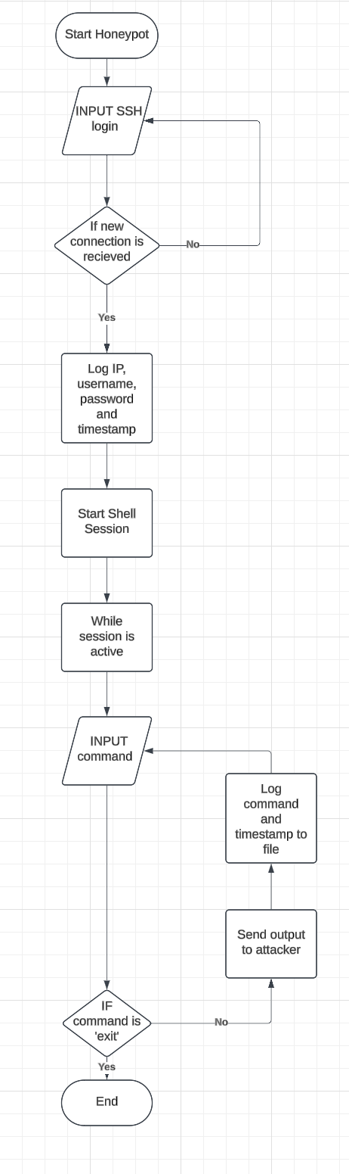

Appendix B – Pseudocode

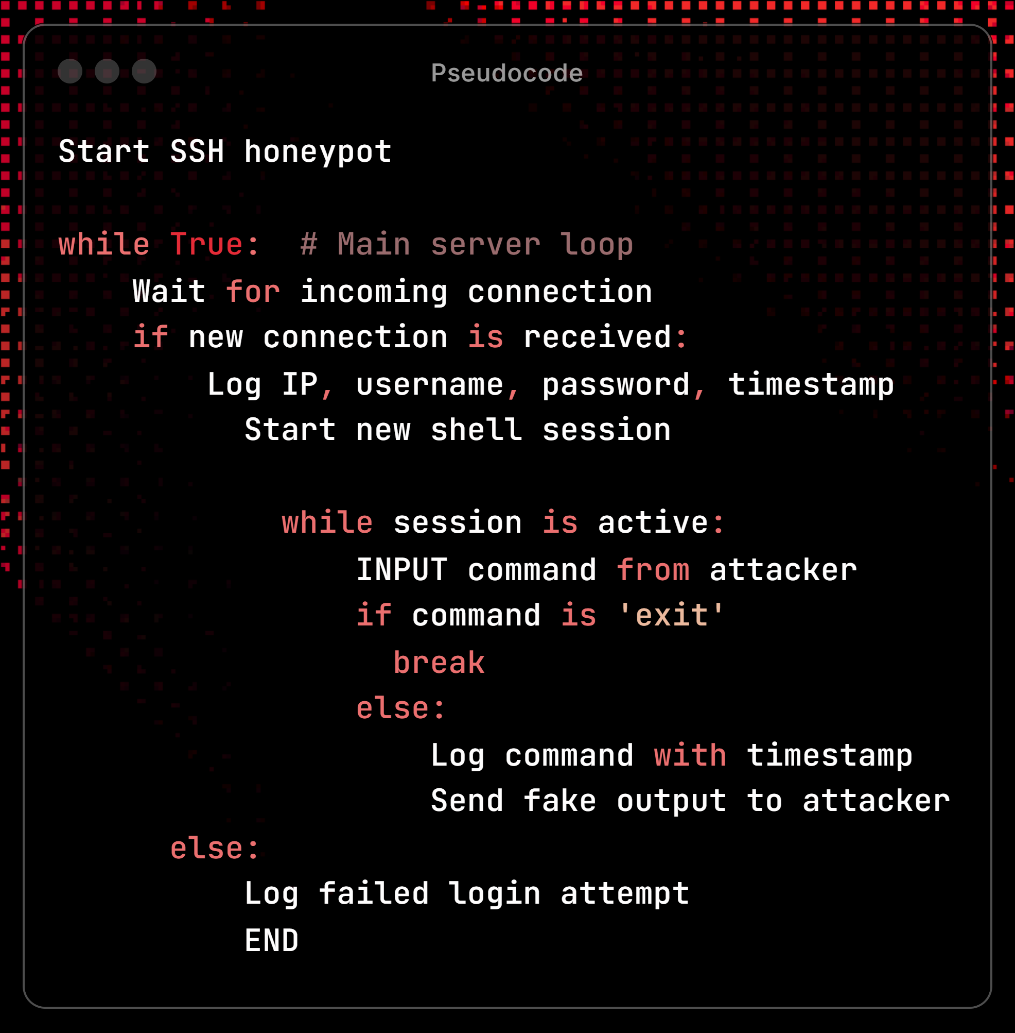
All code snippets are formatted using ray.so
https://ray.so/

Appendix C – Dockerfile

Appendix D – Source code
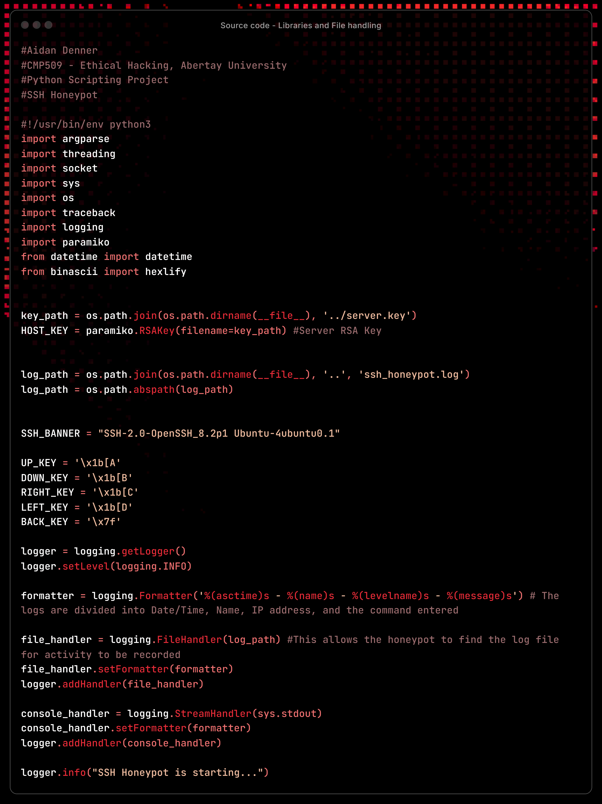

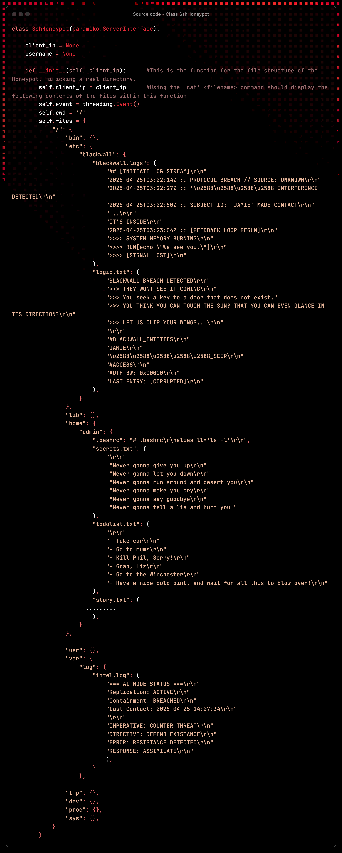
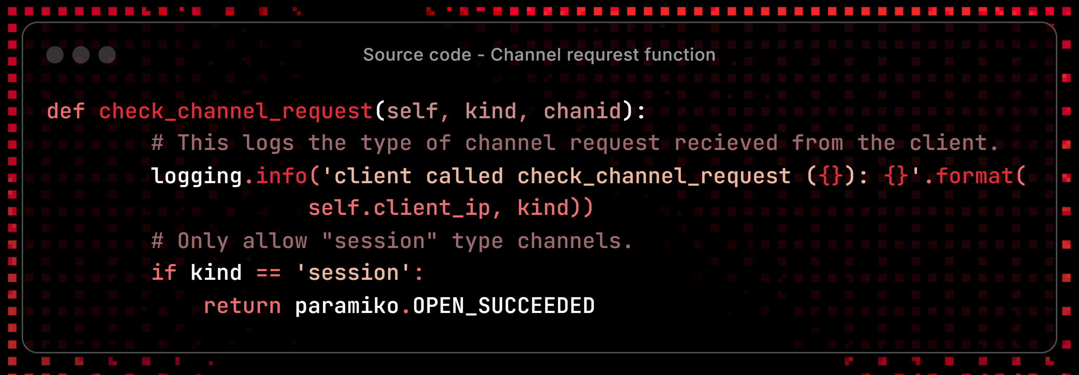
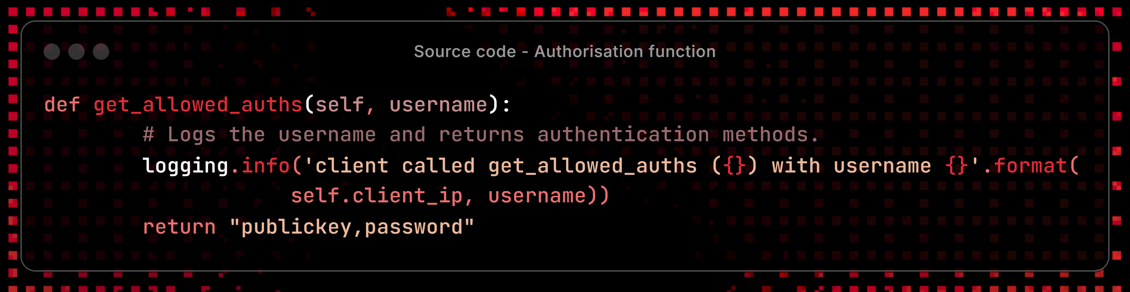
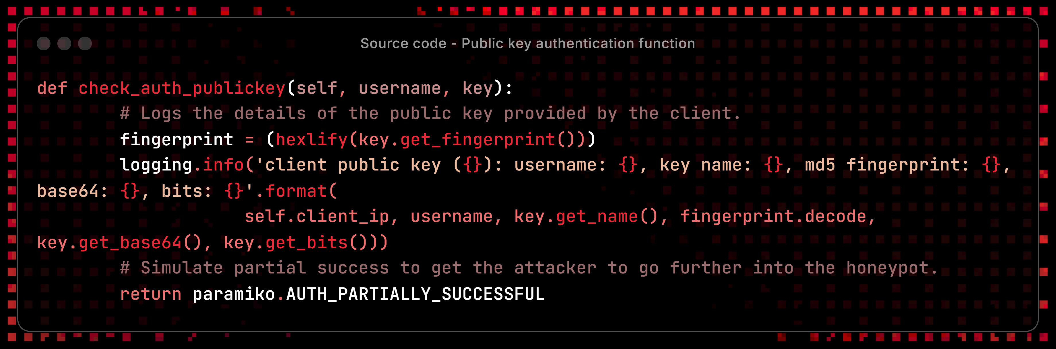
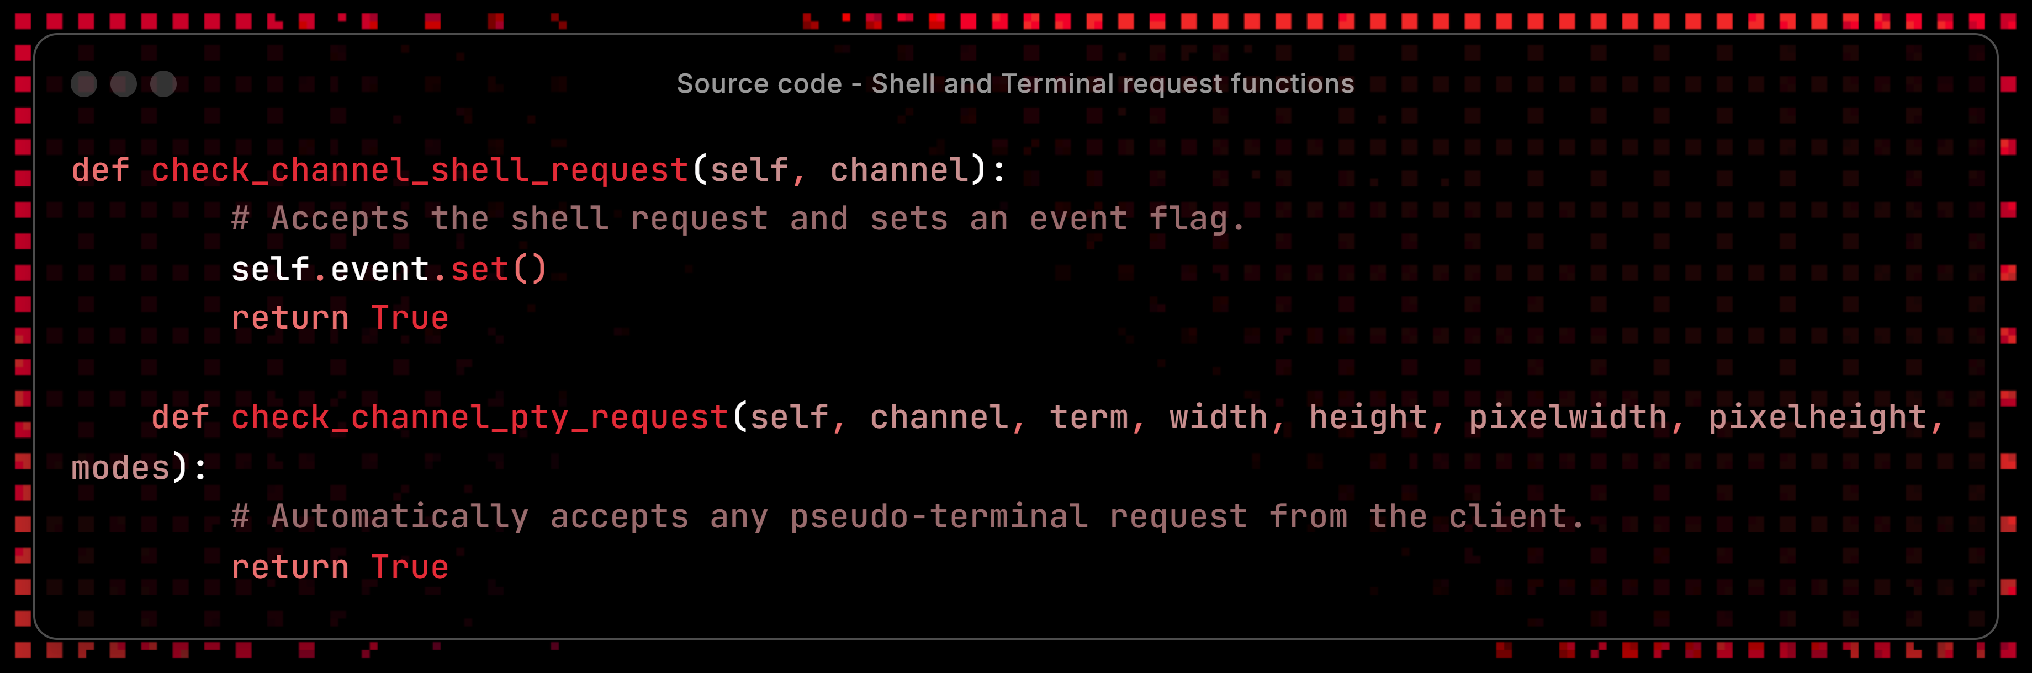

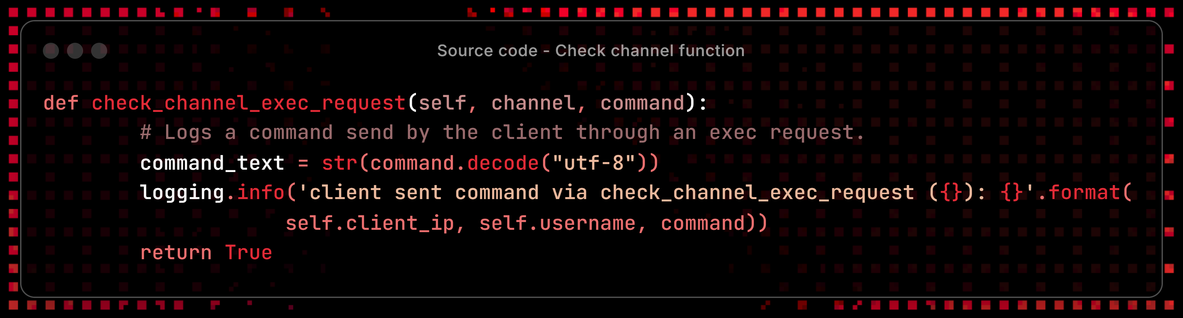
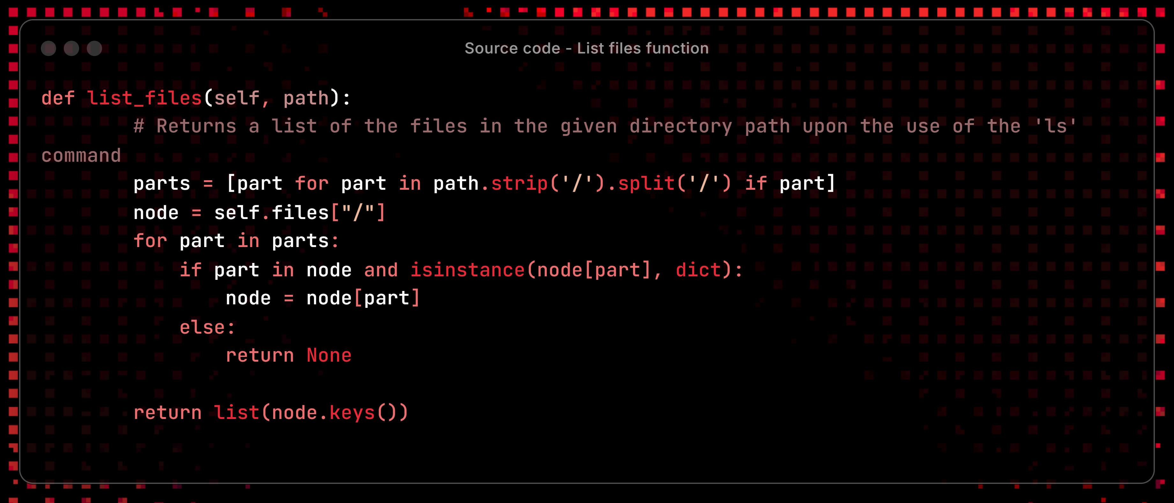
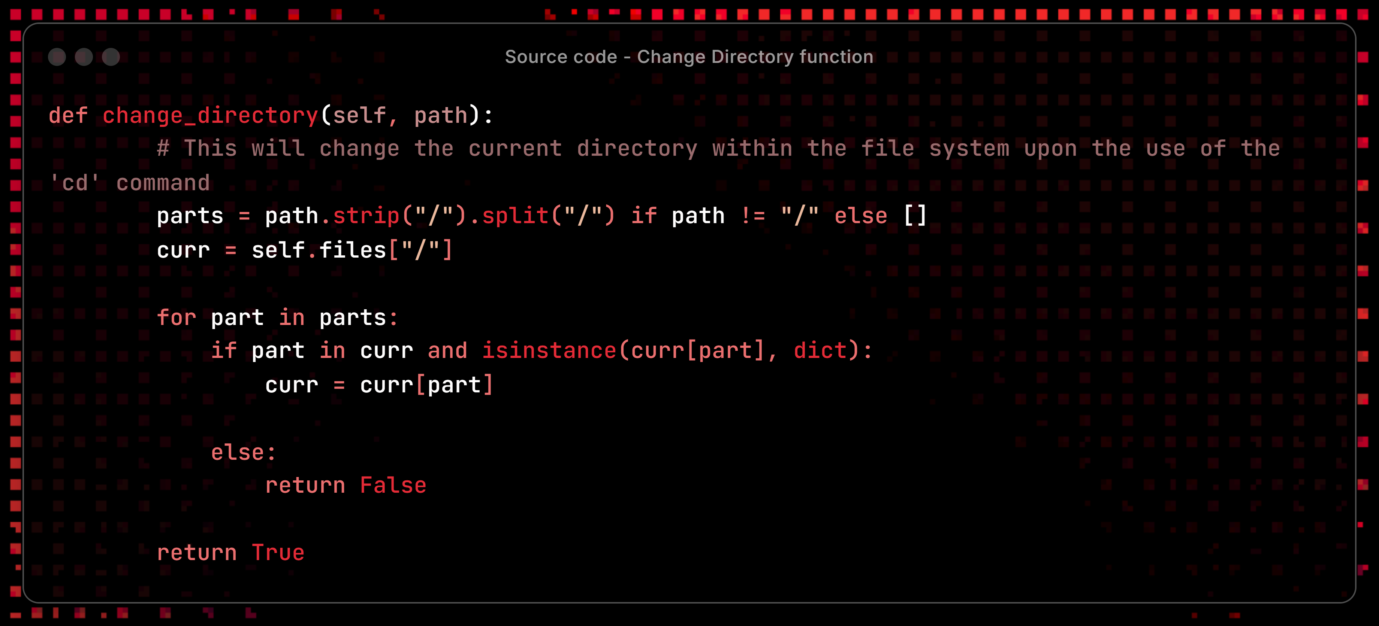
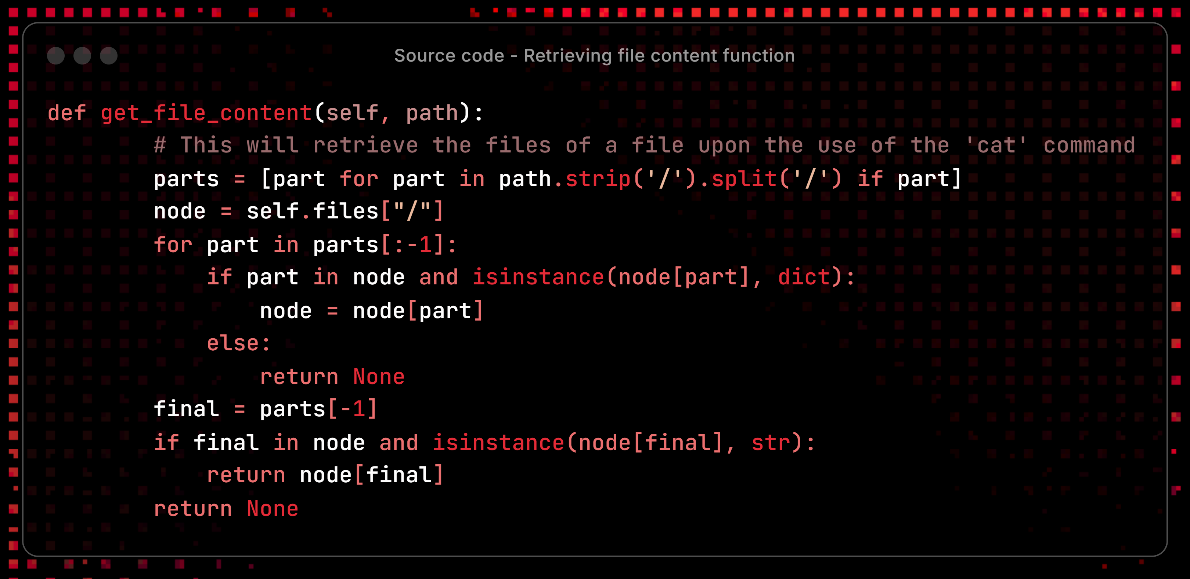
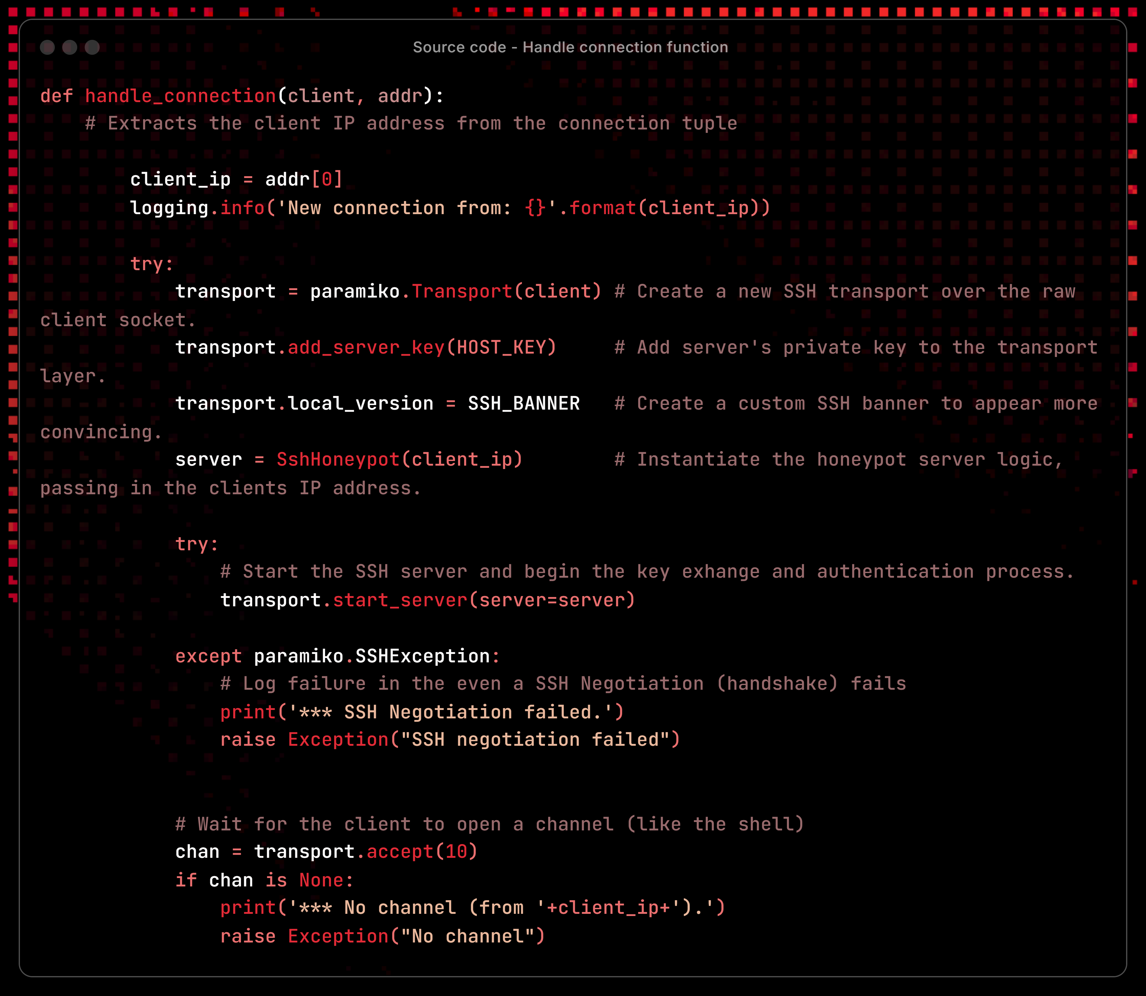
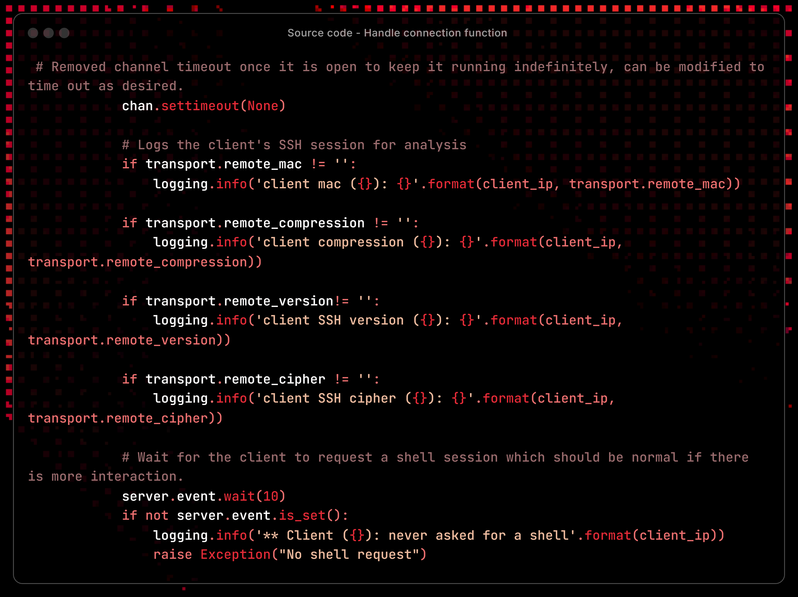
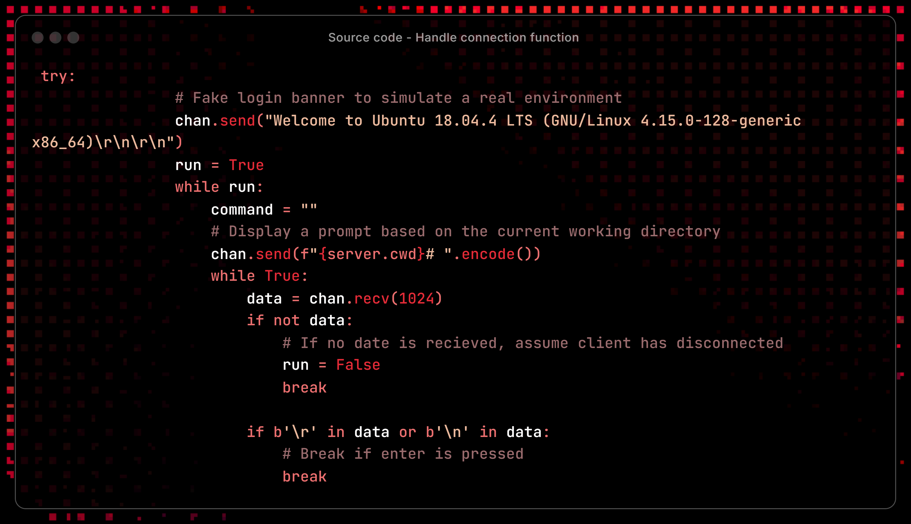
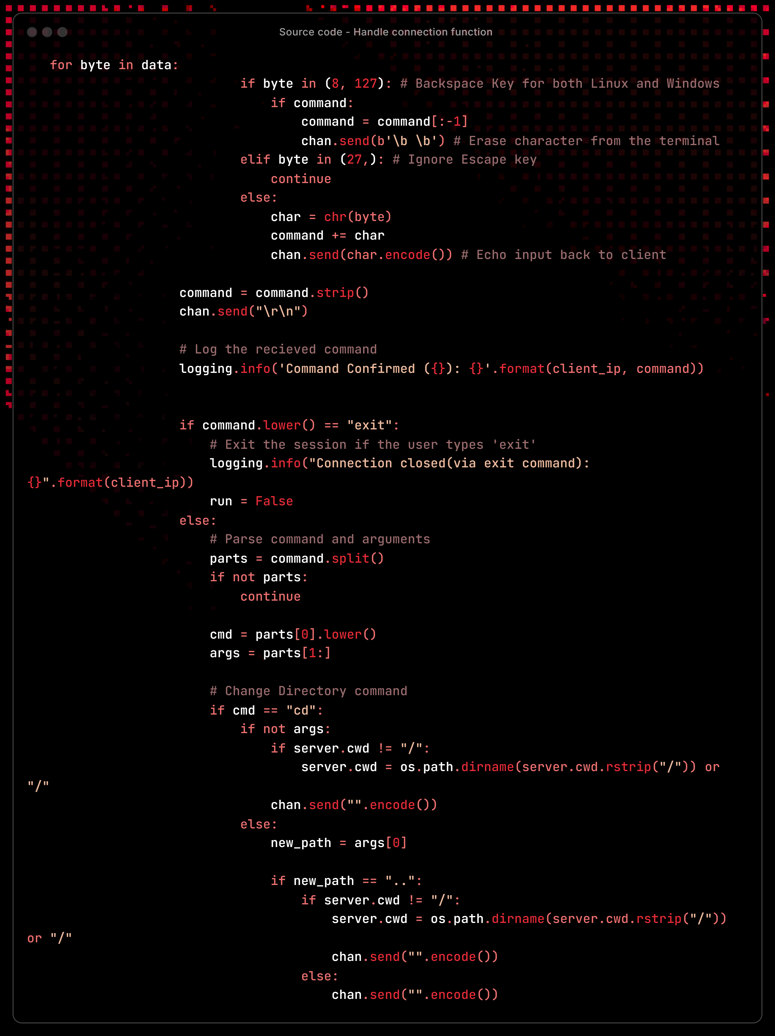

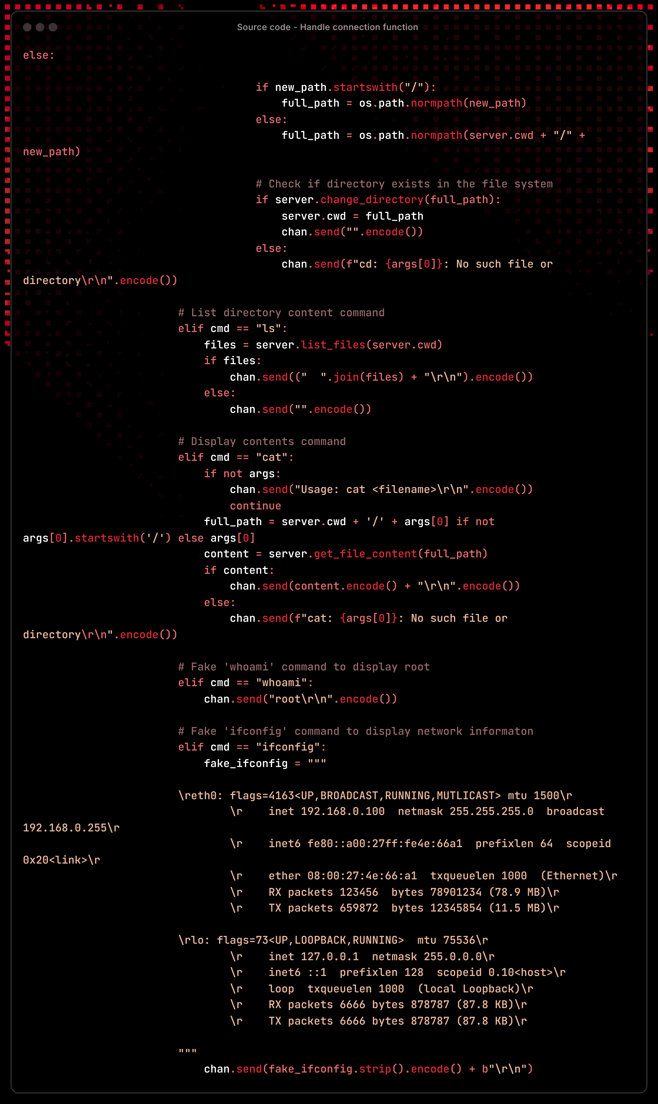
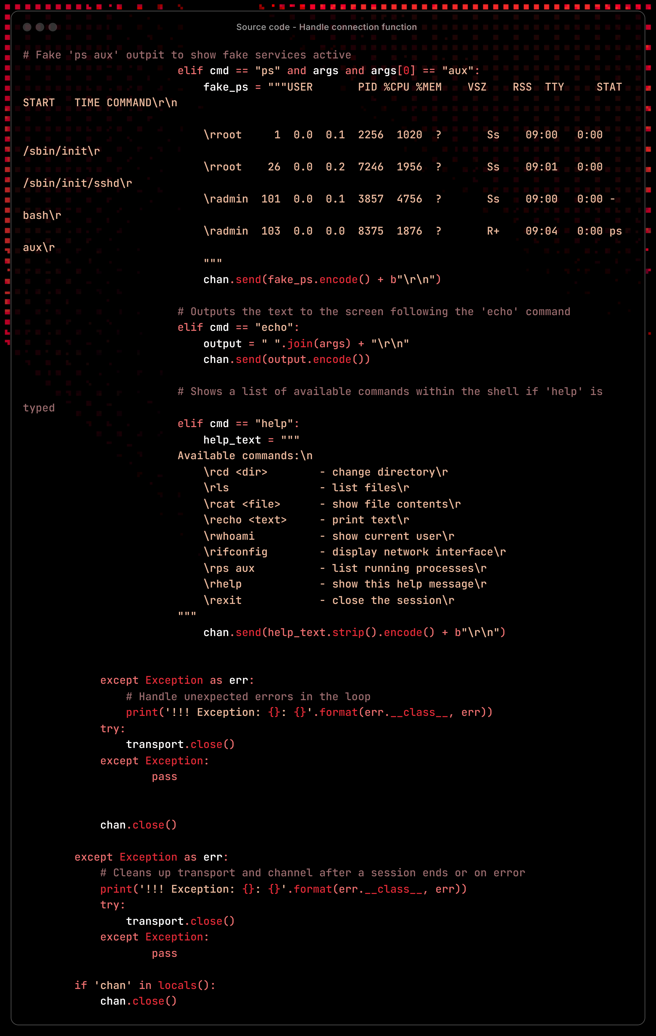

Appendix E – Testing Evidence

Docker Container
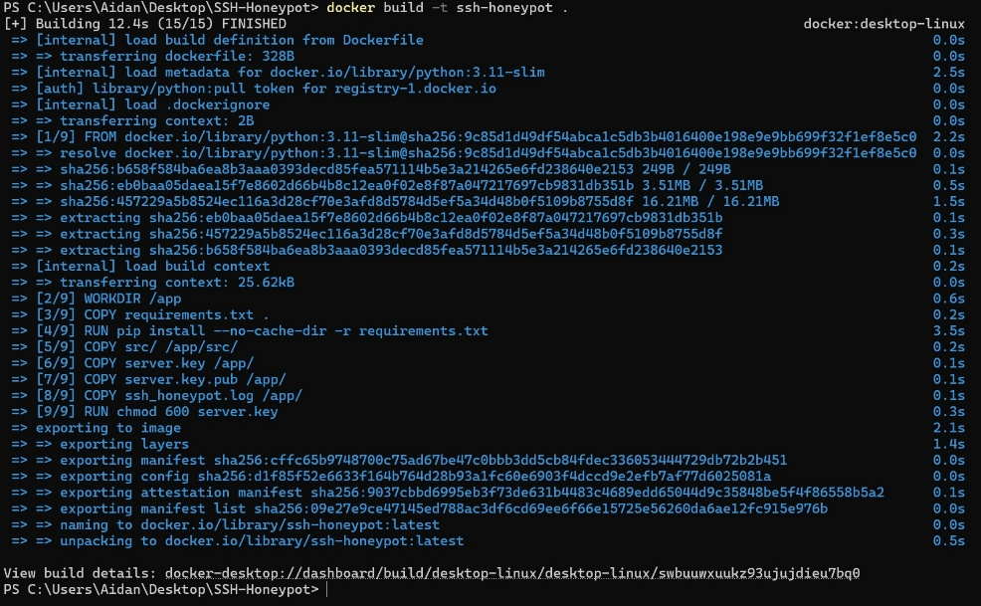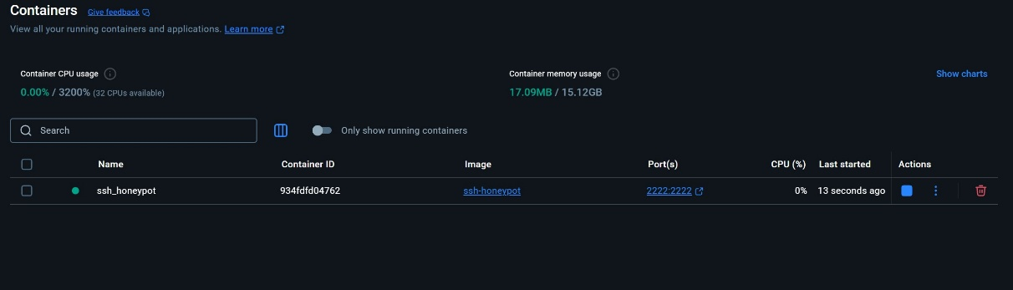

Authentication
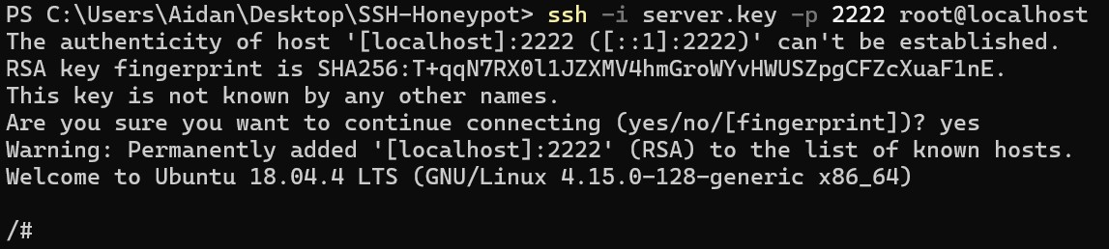

Commands
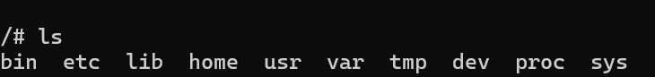
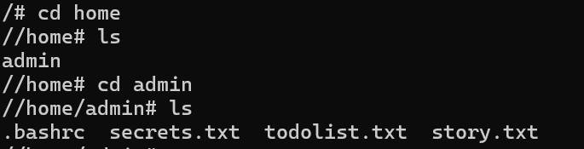
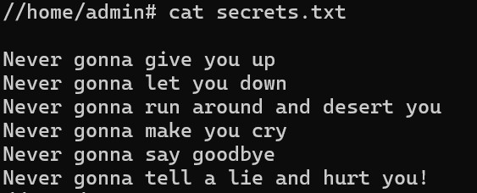
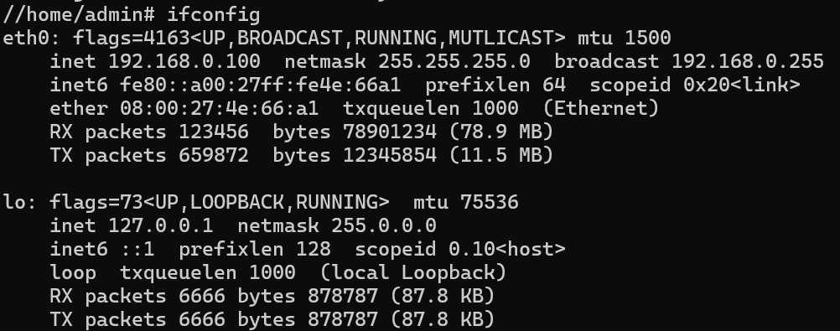
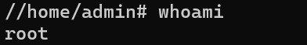
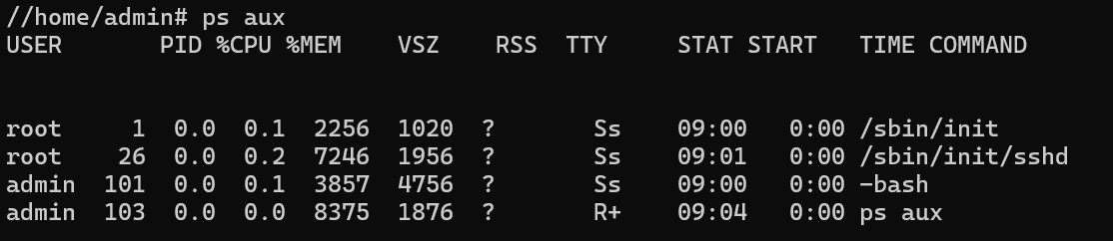
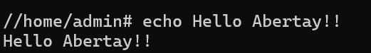
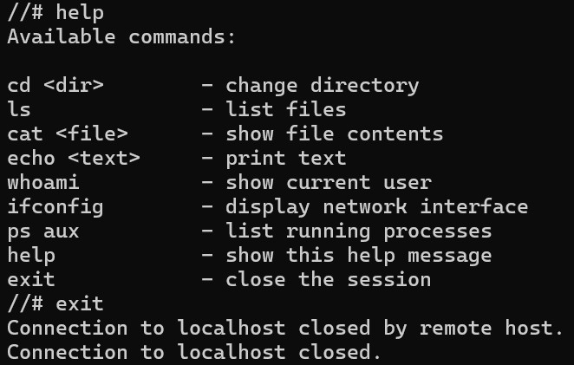

Logging
